Mini-Lesson 3.5: Implementing RNNs [30 minutes]
In this mini-lesson, you will learn how to implement RNNs so that you are prepared to do so for the next Codio activity. By the end of this mini-lesson, you will be prepared to run an implementation of RNNs.
Select to expand the lesson.

Lesson:
Recurrent neural networks (RNNs) are a type of artificial neural network designed to recognize patterns in sequences of data, such as text, speech, or time series. Unlike traditional feedforward neural networks, which process input data in a single direction, from input to output, RNNs have connections that form directed cycles, allowing them to exhibit dynamic temporal behavior. This enables them to maintain a memory of previous inputs, making them well-suited for tasks that involve sequential data. In an RNN, each neuron (or node) in the network receives input not only from the previous layer's neurons but also from its own previous time step, creating a feedback loop. This feedback loop allows RNNs to maintain a state or memory of previous inputs, which can be useful for tasks such as speech recognition, language modeling, and machine translation.
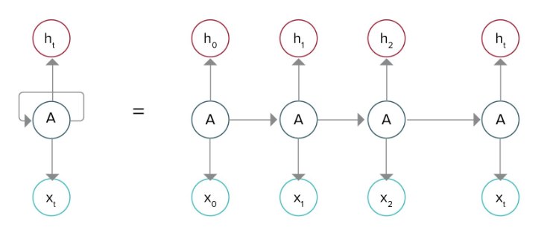
A simplified way of representing the RNN is by unfolding/unrolling the RNN over the input sequence. For example, if a sentence as input to the RNN has ten words, then the network would be unfolded such that it has ten neural network layers.
Types of RNN
RNNs were introduced to store results of previous outputs in the internal memory. There are four types of RNN:
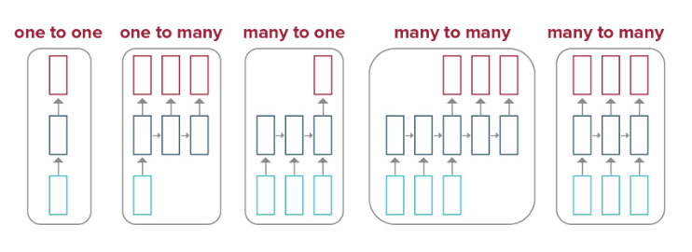
- One-to-one: This has one input and one-p output. It has fixed input and output sizes and is commonly used in image classification.
- One-to-many: One-to-many is a type of RNN that expects multiple outputs on a single input given to the model. The input size is fixed and gives a series of data outputs. Its applications can be found in applications such as music generation and image captioning.
- Many-to-one: A many-to-one RNN converges a sequence of inputs into a single output by a series of hidden layers learning the features. Sentiment analysis is a common example of this type of RNN.
- Many-to-many: Many-to-many RNNs are used to generate a sequence of output data from a sequence of input units. The input and output sizes may or may not be equal. This is commonly used in machine translation.
Different Architectures of RNNs
The three most popular types of RNNs are:
- Bidirectional recurrent neural networks (BRNNs): BRNNs process input sequences in both forward and backward directions, allowing the network to capture information from past and future time steps simultaneously, making them especially effective for tasks where context from both directions is important, such as sequence labeling or sequence-to-sequence tasks.
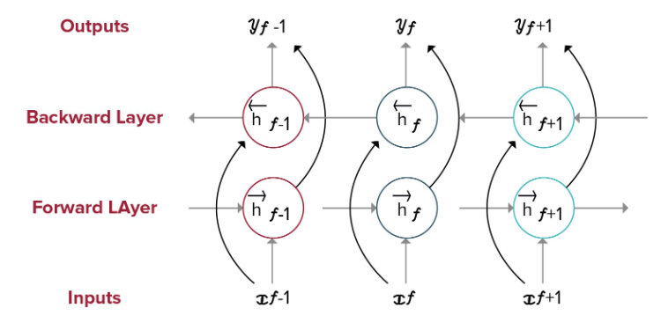
- Gated recurrent units (GRUs): This is another type of RNN architecture, similar to long short-term memory (LSTM) networks. GRUs combine the forget and input gates into a single "update gate," which controls how much of the past information should be passed along to the future. Additionally, GRUs have a "reset gate" that helps the model decide how much of the past information to forget. The key difference between GRUs and LSTMs is the way they manage and use their memory cells.
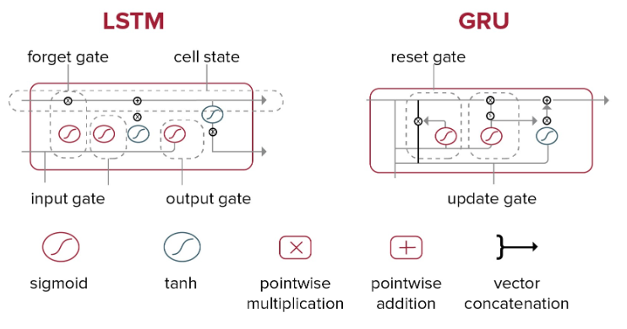
- Long short-term memory (LSTM): LSTM networks are designed to overcome the vanishing gradient problem of traditional RNNs, which occurs when the gradients of the loss function become very small, leading to difficulties in learning long-range dependencies. LSTM is useful in a variety of sequential data tasks as it is well suited for learning and remembering patterns over long sequences.
For more information on GRU and LSTM, see Illustrated Guide to LSTM’s and GRU’s: A step by step explanation Links to an external site.
Applications of RNNs
- Natural language processing:
  - Language modeling: Predicting the next word in a sentence
  - Text generation: Generating text based on learned patterns in data
  - Machine translation: Translating text from one language to another
  - Speech recognition: Transcribing spoken words into written text
- Time series prediction:
  - Stock price forecasting: Predicting future stock prices based on historical data
  - Weather forecasting: Predicting weather conditions such as temperature and humidity
- Music generation:
  - Automatically composing music by learning patterns and styles from various music sequences
- Video analysis:
  - Activity recognition by understanding the sequence of frames in videos

